**MISSAEL COLIN CUEVAS**

**EXTRA CREDIT #1**

**First reading**

The Lorenz system is a system of ordinary differential equations with a very interesting set of chaotic solutions. It is really interesting when plotted as the parameter p increases the result is in a fact a complex butterfly effect.

**Second reading**

Chaos theory studies the behavior of dynamical systems that are highly sensitive to initial conditions popularly known as the butterfly effect. Its behavior is really hard or impossible to describe because it depends of the initial conditions. In other words, you can find its behavior until a determinate point but after that it becomes almost impossible. This kind of behavior, is presented in many natural systems such as weather and climate.

**Strange Attractors - The butterfly effect (Video)**

It is impossible to explain the infinity amount of data.

Lorenz simplified and simplified data to approximate this data in a simple equation.

Lorenz saw that when we solve the equation we solve the behavior of weather…

Chaos is the sensitive dependence of initial conditions. The organizer called this phenomena “butterfly effect”. The idea that a butterfly affects the world is endless, but it has been really powerful. Interpret small causes and small consequences.

Lorenz system is very powerful, trajectories are crazy and unpredictable, but they accumulate on the same butterfly shaped object. This accommodation no depends of the initial position. That is referred to Lorenz attractor.

All atmospheres accumulate in the same butterfly. Instead of describing the future, we try to describe the reactor.

There was propose a model to understand Lorenz reactor.

The field depends the parameter A. As the number initial conditions increase they attract to the same curve. This is not chaotic. But when the parameter change the trajectory doubles …. And this speed up. As parameter A increases it returns to a single predictable behavior.

Bifurcation diagram. Not easy to understand

**Chapter 9 : Chaotic or not - Research today (video)**

According to Lorenz, the proportion of time that trajectory speeds in a ball converges to a limit that no depends of the initial condition. However this is not true in all trajectories.

The trajectory of the ball is closed to a 100 percent but then it waits more… infinitely times, so there is not convergence. But this is very special. Regularly, every element falls in this trajectory.

**MATLAB code:**

clear; clc; close all

N = 1000000;

t = linspace(0,100,N);

dt = t(2)-t(1);

t(1) = 0;

s=10;

b=8/3;

r=28;

x(1) = 1;

y(1) = 1;

z(1) = 1;

for i = 2:N

%Predictor Corrector

xstar = x(i-1)+dt*(x(i-1));

ystar = y(i-1)+dt*(y(i-1));

zstar = z(i-1)+dt*(z(i-1));

x(i) = x(i-1)+dt/2*s*(ystar-xstar);

y(i) = y(i-1)+dt/2*(r*xstar + ystar -(xstar* zstar));

z(i) = z(i-1)+dt/2*(-b*zstar+xstar*ystar);

end

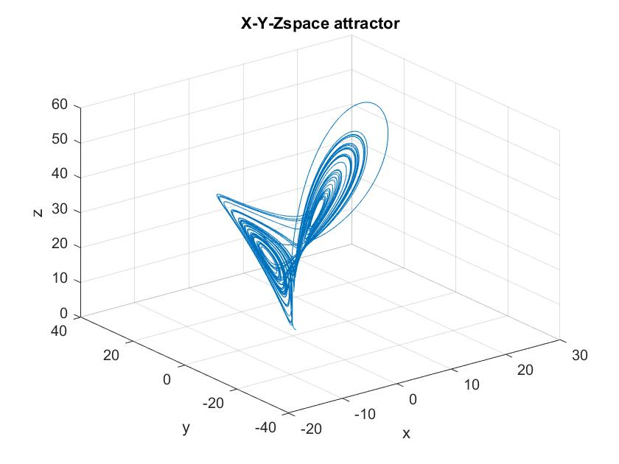plot3(x,y,z)

xlabel('x'), ylabel('y'), zlabel('z')

title('X-Y-Zspace attractor')

grid on

6.- The chaos occurs when the number of initial conditions increase. It makes that phenomena unpredictable.